Android App Development

(m/f/x) @ Cambridge-led

ALPS Project

**Description of content**

The goal of Automated Licensing Payment Systems (ALPS) is to enhance accuracy and trust and reduce uncertainty as well as overall transaction costs in the licensing of Intellectual Property (IP). The system enables novel business models and contributes to fairer remuneration of the IP owners for the value their assets generate in the industry.

Most currently, an automated licensing payment system (ALPS) is being developed by a team of scholars, students and industry experts combining expertise from Technology Management, Innovation and Intellectual Property. This system will include digital infrastructure that enables the automated calculation, execution and verification of accurate payments from licensees and their customers to licensors.

**What we will do?**

As a contributor to this project, we will develop an Android application which collects usage time of some sensors on Android Smart Phones e.g. Bluetooth, Wifi, Screen activation, etc. After that, the application sends this usage data to an already created and ready simulated DLT. This will enable more thorough and realistic testing scenarios.

More specifically, we are going to create an application that welcomes users with a classical login screen. The data entered in this screen will be held and stored locally in the application to label the user later on. As the user inputs his/her credentials, we’ll show two different screens to the user.

The first screen will consist of a tool to start collecting user data. As mentioned above in this document, we are asked to collect sensor data of the device. By using this screen, users will be able to start collecting data and later on, stop the collecting. One of the crucial tasks in this is that the device will collect the data even in the background.

The second screen will include a dashboard of previously collected data. Using this screen, users will be able to look at how much their sensors qualitatively and quantitatively are used. In addition, there will be an option to send this data to the provided API endpoint. The data saved here will be used to improve the system.

In addition to the newly developed application, we’ll also create and publish a project report which includes more technical details about the whole process.

**Description of relationship between project and application area**

The marketing management is shaped with resources that are being used by humans or as in the tech sector, users. One of the main aspects of the area is the price of resources or any products that we buy. In this context, the price does not just mean using an exchange medium but also time and the energy that a customer spends.

In our project, a DLT-simulation based system will compute the licensing payment. By using this application, we will help to create a better and efficient cost structure which is based on time that a user spends with his/her license. In addition to all, this transaction of user and the system will be secure and safe.

**Justification of choice of lecture – How does it fit into concept?**

We will study and complete a lecture that consists of two parts. The first part is the Marketing. This lecture explains the marketing strategies and pricing models with the examples given from the real world systems.

The second lecture is Technology and Innovation Management. This lecture on the other hand focuses more on the technology and the innovations it created for the marketing applications.

**Milestones**

1. Milestone

09.11.2020 - 21.12.2020

1. Milestone

21.12.2020 - 15.02.2021

1. Milestone

15.02.2021 - 15.03.2021

**Timetable**

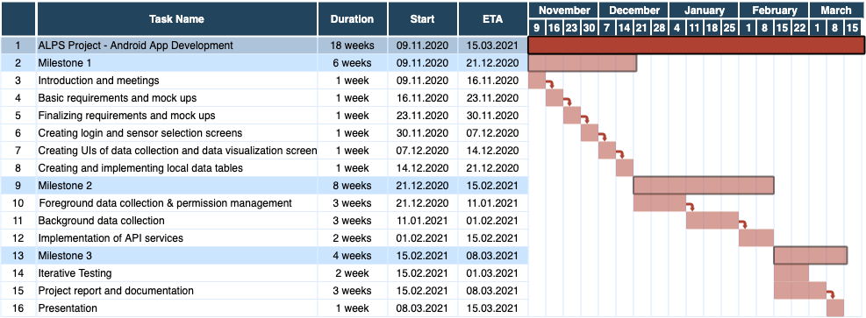

**Participants**

Berke Esmer

Ece Ata